Abraham, Sarah, and the Visitors
A Cooking Workshop Lesson
Summary of Lesson Activities:
Children make the foods mentioned in the passage that Sarah served to her heavenly visitors.
Scripture Reference:
Genesis 18:6-8

Leader Preparation:
- Read the scripture ahead of time.
- Gather the materials.
- Prepare the dough.
Supplies List:
- 1 ½ cups wheat berries (wheat berries are whole wheat kernels) (1 cup to cook and ½ cup to show children)
- Olive oil
- Large, heavy frying pan (for roasting wheat berries)
- Sarah’s unleavened bread dough (prepared ahead of time, recipe below)
- Cheese balls (made from curds you make with milk you sour with lemon juice or vinegar and strain, recipe below)

Presentation
Opening- Welcome and Lesson Introduction:
Greet the children and introduce yourself.
Say: We’ve been learning about God’s Promise to make Abraham “the father of many nations”; that his descendants would be as many as the stars or as the grains of sand.
During your time in the Milk & Honey Café we’ll be teaching you about foods that were served and eaten during Bible times. Often, we’ll be making and eating something written about in the bible stories you are learning.
Dig-Main Content and Reflection:
Let’s read some of the story you have been learning about:
Genesis 18:6-8 6 So Abraham ran back to the tent and said to Sarah, "Quick! Get three measures of your best flour, and bake some bread." 7 Then Abraham ran out to the herd and chose a fat calf and told a servant to hurry and butcher it. 8 When the food was ready, he took some cheese curds and milk and the roasted meat, and he served it to the men.
This event, Abraham showing hospitality to his three visitors who were messengers from God; is the first time the bible talks about bread or baking. The kind of flour used in this passage is finely ground wheat. Three measures means about 28 cups!!! So Abraham wanted Sarah to make enough bread to feed the guests and the whole camp (Abraham’s family, his servants, retainers and their families) as well!
Show the children the whole wheat berries. Roast some berries in front of the children and serve some that you prepared ahead of time.
Roasted Wheat Berries
1 cup wheat berries
1 tablespoon of olive, sesame or other neutral oil
Salt to taste
Heat a small amount of oil in a large, heavy frying pan over a fire or a burner on your stove. Add a handful of the dry wheat berries and shake the pan frequently to cook them evenly and to keep them from sticking. When they puff up, they are ready to eat, and you are ready to start a new batch. Sprinkle with salt before serving. Note that the wheat berries will puff up less than popcorn, but will still be quite cooked.
Share this recipe with the kids in your own words (have the dough prepared ahead of time and ready to let the kids roll out and then cook on the stove top or in the oven. Baking in the oven will probably be faster). Then you can proceed with the cheese activity.
Sarah’s Unleavened Bread
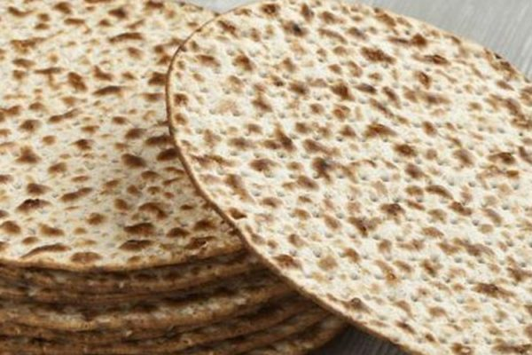Basically just:
wheat flour
1 tsp salt
¾ cup lukewarm water
Sesame or vegetable oil
Alternatively, you could make soft "pita" style bread with yeast.
Look for a pita bread or unleavened bread on allrecipes.com. They are varied and plentiful.
Say: Abraham also served his guests cheese curds. What do you think those are?
In biblical times every family made fresh cheese from the extra milk of the sheep, goats, and cows they kept. Making cheese was a way to preserve the extra milk so nothing went to waste. Plus, making cheese concentrates the milk proteins and was an important source of nutrition. One gallon of fresh milk makes 1 ½ pounds of cheese and several cups of whey (the liquid left over after making cheese). The whey was often used in soups and stews.
To make cheese with the milk you get from the store, add 1 tablespoon of lemon juice or vinegar to two cups of lukewarm milk. Heat this sour milk over low heat until solids separate. The solid mass is called clabber. Pour the clabber into a strainer or colander lined with a double layer of cheesecloth. Place the colander or strainer over a bow to catch the whey. Andy clean, open weave, un-dyed fabric may be substituted for cheesecloth (2 layers of wet paper toweling will do in a pinch). Let the cheese drip overnight or at least 6 hours. Form the cheese into small balls and eat plain or seasoned.
Prepare the cheese ahead of time, but tell the children how you did this (above) and serve the cheese balls with the bread and wheat berries.
Read: Genesis 18:6-8 6 So Abraham ran back to the tent and said to Sarah, "Quick! Get three measures of your best flour, and bake some bread." 7 Then Abraham ran out to the herd and chose a fat calf and told a servant to hurry and butcher it. 8 When the food was ready, he took some cheese curds and milk and the roasted meat, and he served it to the men.
Ask:
- How long do you think it took the servants to “hurry and butcher” a fat calf? A fatted calf as referred to in the bible is not beef, it is a young goat or a lamb.
- How long do you think it took to roast the meat? The animal was probably spitted from the mouth to just below the tail and roasted over a bed of coals, with servants turning the spitted meat and basting it with oil. According to the book that we are using, The Good Book Cook Book, “the roasting of a fatted calf is not a hurried affair”. It takes several hours depending on the size of the “fatted calf” and the heat of the fire.
- How long do you think it took Sarah to prepare the bread? The recipe we used requires at least 1 hour and 40 minutes, not including the time it takes to grind the wheat berries and the baking time.
- How long do you think it took to make the cheese curds? The recipe we used requires at least 6 ½ hours.
Closing:
Wrap some bread with a napkin so students can share it and the story at home. Have them write some notes on the napkin.
NOTE: We used The Good Book Cookbook, by Naomi Goodman, Robert Marcus and Susan Woolhandler for our recipes, ISBN 0-8007-1706-6

A lesson from First Nazarene
San Benito, TX
A representative of Rotation.org reformatted this post to improve readability.

