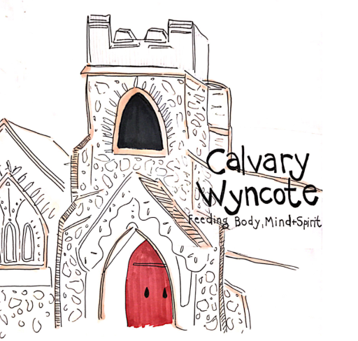
INTRODUCTion

“an abiding purpose to be good citizens and good neighbors,
with sympathy and help in every possible way.”
Sept, 1896 - Founding Values of Calvary Presbyterian Church, Wyncote

Nestled in historic Wyncote, and housed in a beautiful stone church built in 1899, Calvary Presbyterian Church, Wyncote, is actively seeking ways to grow as a center of worship, faith and inclusivity, and to continue to be good citizens and good neighbors to the Wyncote community. At the beginning of this new decade, we wish to renew our emphasis on partnership and community, recognizing that the sustainability of our congregation, our buildings, our mission, and our place in the community challenges us to be innovative and open to sharing our space with groups and organizations that share our values. We seek to achieve sustainability as an asset for the Wyncote community and the wider world. We are engaged in an effort to form partnerships that will strengthen our mission efforts and share our beautiful, historic building.

Legacy
Founded as a mission church in 1891, Calvary was established to serve the summer visitors who came by train from Philadelphia as well as the wealthy industrialists who were building homes in the area. A dedicated group of people from different faiths (Presbyterian, Methodist, Lutheran and Baptist) came together to plan for the construction of the first wooden chapel for this growing congregation. In 1892 the decision was made to petition the Philadelphia Presbytery to form a new church and call the first minister.

The original wood-frame chapel, originally on Greenwood Avenue, was moved to the current location in 1893 and the minister’s home, now known as Fellowship House, was built next door in 1894. Calvary’s membership grew, reflecting the development of the neighborhood, and soon the wood chapel was replaced by the current charming stone Church that has graced this historic district since1899.

Church newsletters beginning in the late 19th century describe services, prayer meetings and congregational updates as well as neighborhood events, lectures and socials. Many mission activities were sponsored, including support of the Union of the Freedmen (formed to support freed slaves), home and foreign missions. In 1893 Calvary began its longstanding practice of offering church facilities for use by organizations outside of the congregation. Approval was given to start a Kindergarten in the building, and permission was given to hold public meetings as well.
The other founding values of the Church identified in the 1896 newsletter still ring true today.

- a non-sectarian spirit
- a voluntary spirit in services, in giving, and in doing
- a devotion to the simple gospel of the Lord Jesus Christ
- a family life in the church
- a constant welcoming of any and all, of whatever faith, who may be willing to come within our circle
- a willingness that others should do their own work in their own way, and a sincere desire for God’s blessing upon them

Our founders had a broad, inclusive vision of the church that is more relevant today than ever. As we move forward in 2020 and beyond, Calvary has the opportunity to build on that vision and further multiply our positive value.

Calvary today
Our current congregation continues to reflect the founding values, with additional emphasis on our warm welcome to visitors of any faith background, ethnicity, disability and/or sexual orientation. We nurture our congregation through continuing education events, music and social gatherings. Our members volunteer over 1000 hours of community service each year and provide over $100,000 in public value to organizations outside the walls of the church.
Mission: Supporting causes both close to home and around the world, Calvary provides financial support to a variety of causes. Here in Cheltenham township, we are currently offering assistance to an immigrant family who are seeking asylum from religious persecution in their home country of Pakistan. For many years we have sponsored a missionary in Bolivia and Peru whose focus is environmental justice. Here on our doorstep in Wyncote, we have helped seniors housed at Phoebe Wyncote retirement home. Our mission donations remain a source of great pride and importance to us and have remained constant even as the size of the congregation has declined.
Hunger: Through our outreach efforts and partnerships with certain local agencies, we have learned a great deal about food insecurity. The notion that there are families in our area who experience hunger every day has hit a chord with our congregation. Feeding the hungry has become a central vision of our church, with a number of Calvary members volunteering regularly at local food cupboards and food kitchens such as the Cedar Park Church Coffee Coupe and the Jenkintown Food Cupboard. In addition to the volunteer hours, the congregation contributes both financial and food support for many of these programs. We also use our church kitchen and our volunteer efforts to make meals for local meal distribution programs such as Caring for Friends.
Beyond the local food insecurity focus, the congregation has for the past five years raised funds for and packaged 10,000 meal packets for the international aid group Rise Against Hunger.
Music: We are blessed with a beautiful sanctuary with remarkable acoustical qualities. We have always opened our doors to the local community for performances and recitals. From Children’s Opera Box to the Montgomery County Chorale and Orchestra, to many local music teachers, we have hosted recitals, performances and even sound recordings. In our own worship, we are proud to boast three high-caliber music ensembles, our Chapel Choir, Chancel Choir and our very own Handbell Choir. Our wonderful, recently - restored pipe organ enhances our service every week.
Civic Space: In addition to the music groups that use our sanctuary, we also host a variety of community organizations in the different spaces in our facility. Cub Scouts, Boy Scouts, several community groups and a variety of Cheltenham Township Adult School classes meet regularly in the space. We host wedding ceremonies and funerals for both members and the wider community in our sanctuary, and receptions in our Fellowship Hall.

The undertaking
In an effort to ensure that the legacy Calvary has created lives on, we are seeking to partner with groups or organizations that share our fundamental values and founding principles. We are open to space - sharing to allow us to make the most of our buildings and to forge new collaborative relationships. Our hope is that the new relationships will increase our value to the community and the wider world; allow Calvary to remain relevant and vibrant, and to continue its current mission of “feeding body, mind and spirit.”

As light shines through the Tiffany stained-glass windows in Calvary Presbyterian Church, it illuminates the building and the people inside, both literally and spiritually.

We are looking forward to sharing the warmth of this light and fellowship that we enjoy with new partners.

WHAT’S NEXT?
Our project management team is eager to hear from you. Please feel free to reach out to us with your comments, suggestions and ideas.

Project Team
- Rick Heimann prheimann@gmail.com
- Lily Heinemann lheinemann@temple.edu
- Lisa Hoag lisa.hoag83@gmail.com
- Belinda Tyler btyler@dpt-law.com
- Pastor Judy Dwyer pastor.judy@calvarypreswyncote.org

Calvary Presbyterian Church, Wyncote
217 Fernbrook Avenue, Wyncote, PA 19095
Telephone: 215-884-5119

